**Session - 2**

**Core Java**

**- Assignment**

**- 1 : Read the code of the String class and prepare a document table : function the**

**argument and the return type charAt : int argue and int & int**

**- 2. Try different functions for the string class.**

**- 3. Print first 100 even numbers.**

**- 4. Print the n odd numbers , starting from s , where both s and n are entered.**

**- Assignment Questions on Loop:**

**- 5. You have check of the number entered by the user is PRIME OR NOT.**

**- 6. You have check of the number entered by the user is PALINDROME OR NOT.**

**(121) : type should be int**

**- 7. WAP to check if the number is Armstrong or not. (125) : cube of 1 + cube of 2 +**

**cube of 5 = 125**

Answers for Question 3 – 7

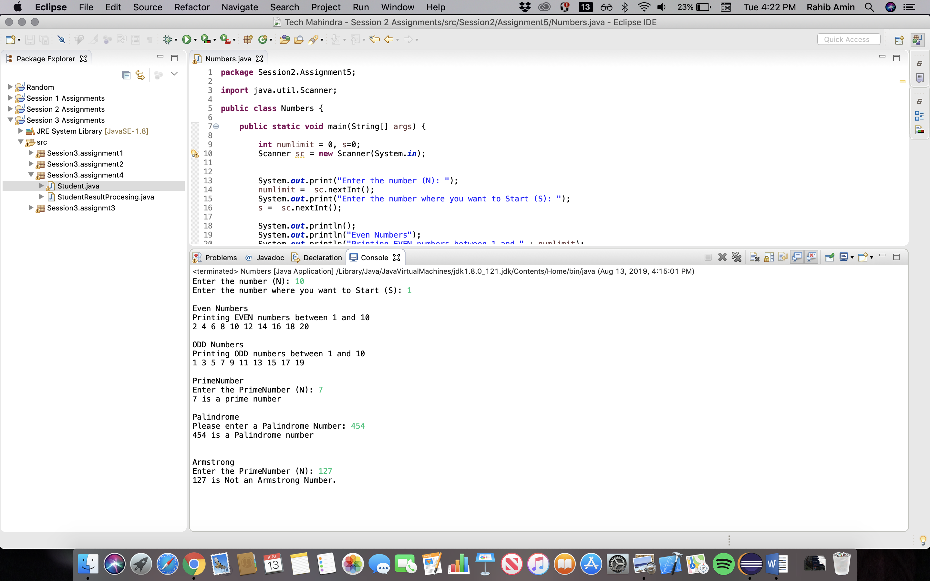

**- 8. WAP to check if we have to remove any repeated character in a STRING.**

**• Example : “HelloWorld” : multiple : HeloWrd**

**- 9. Print all the combinations of characters entered. First input the number of**

**characters n and following you will input n alphabets. Don't accept**

**repeating characters.**

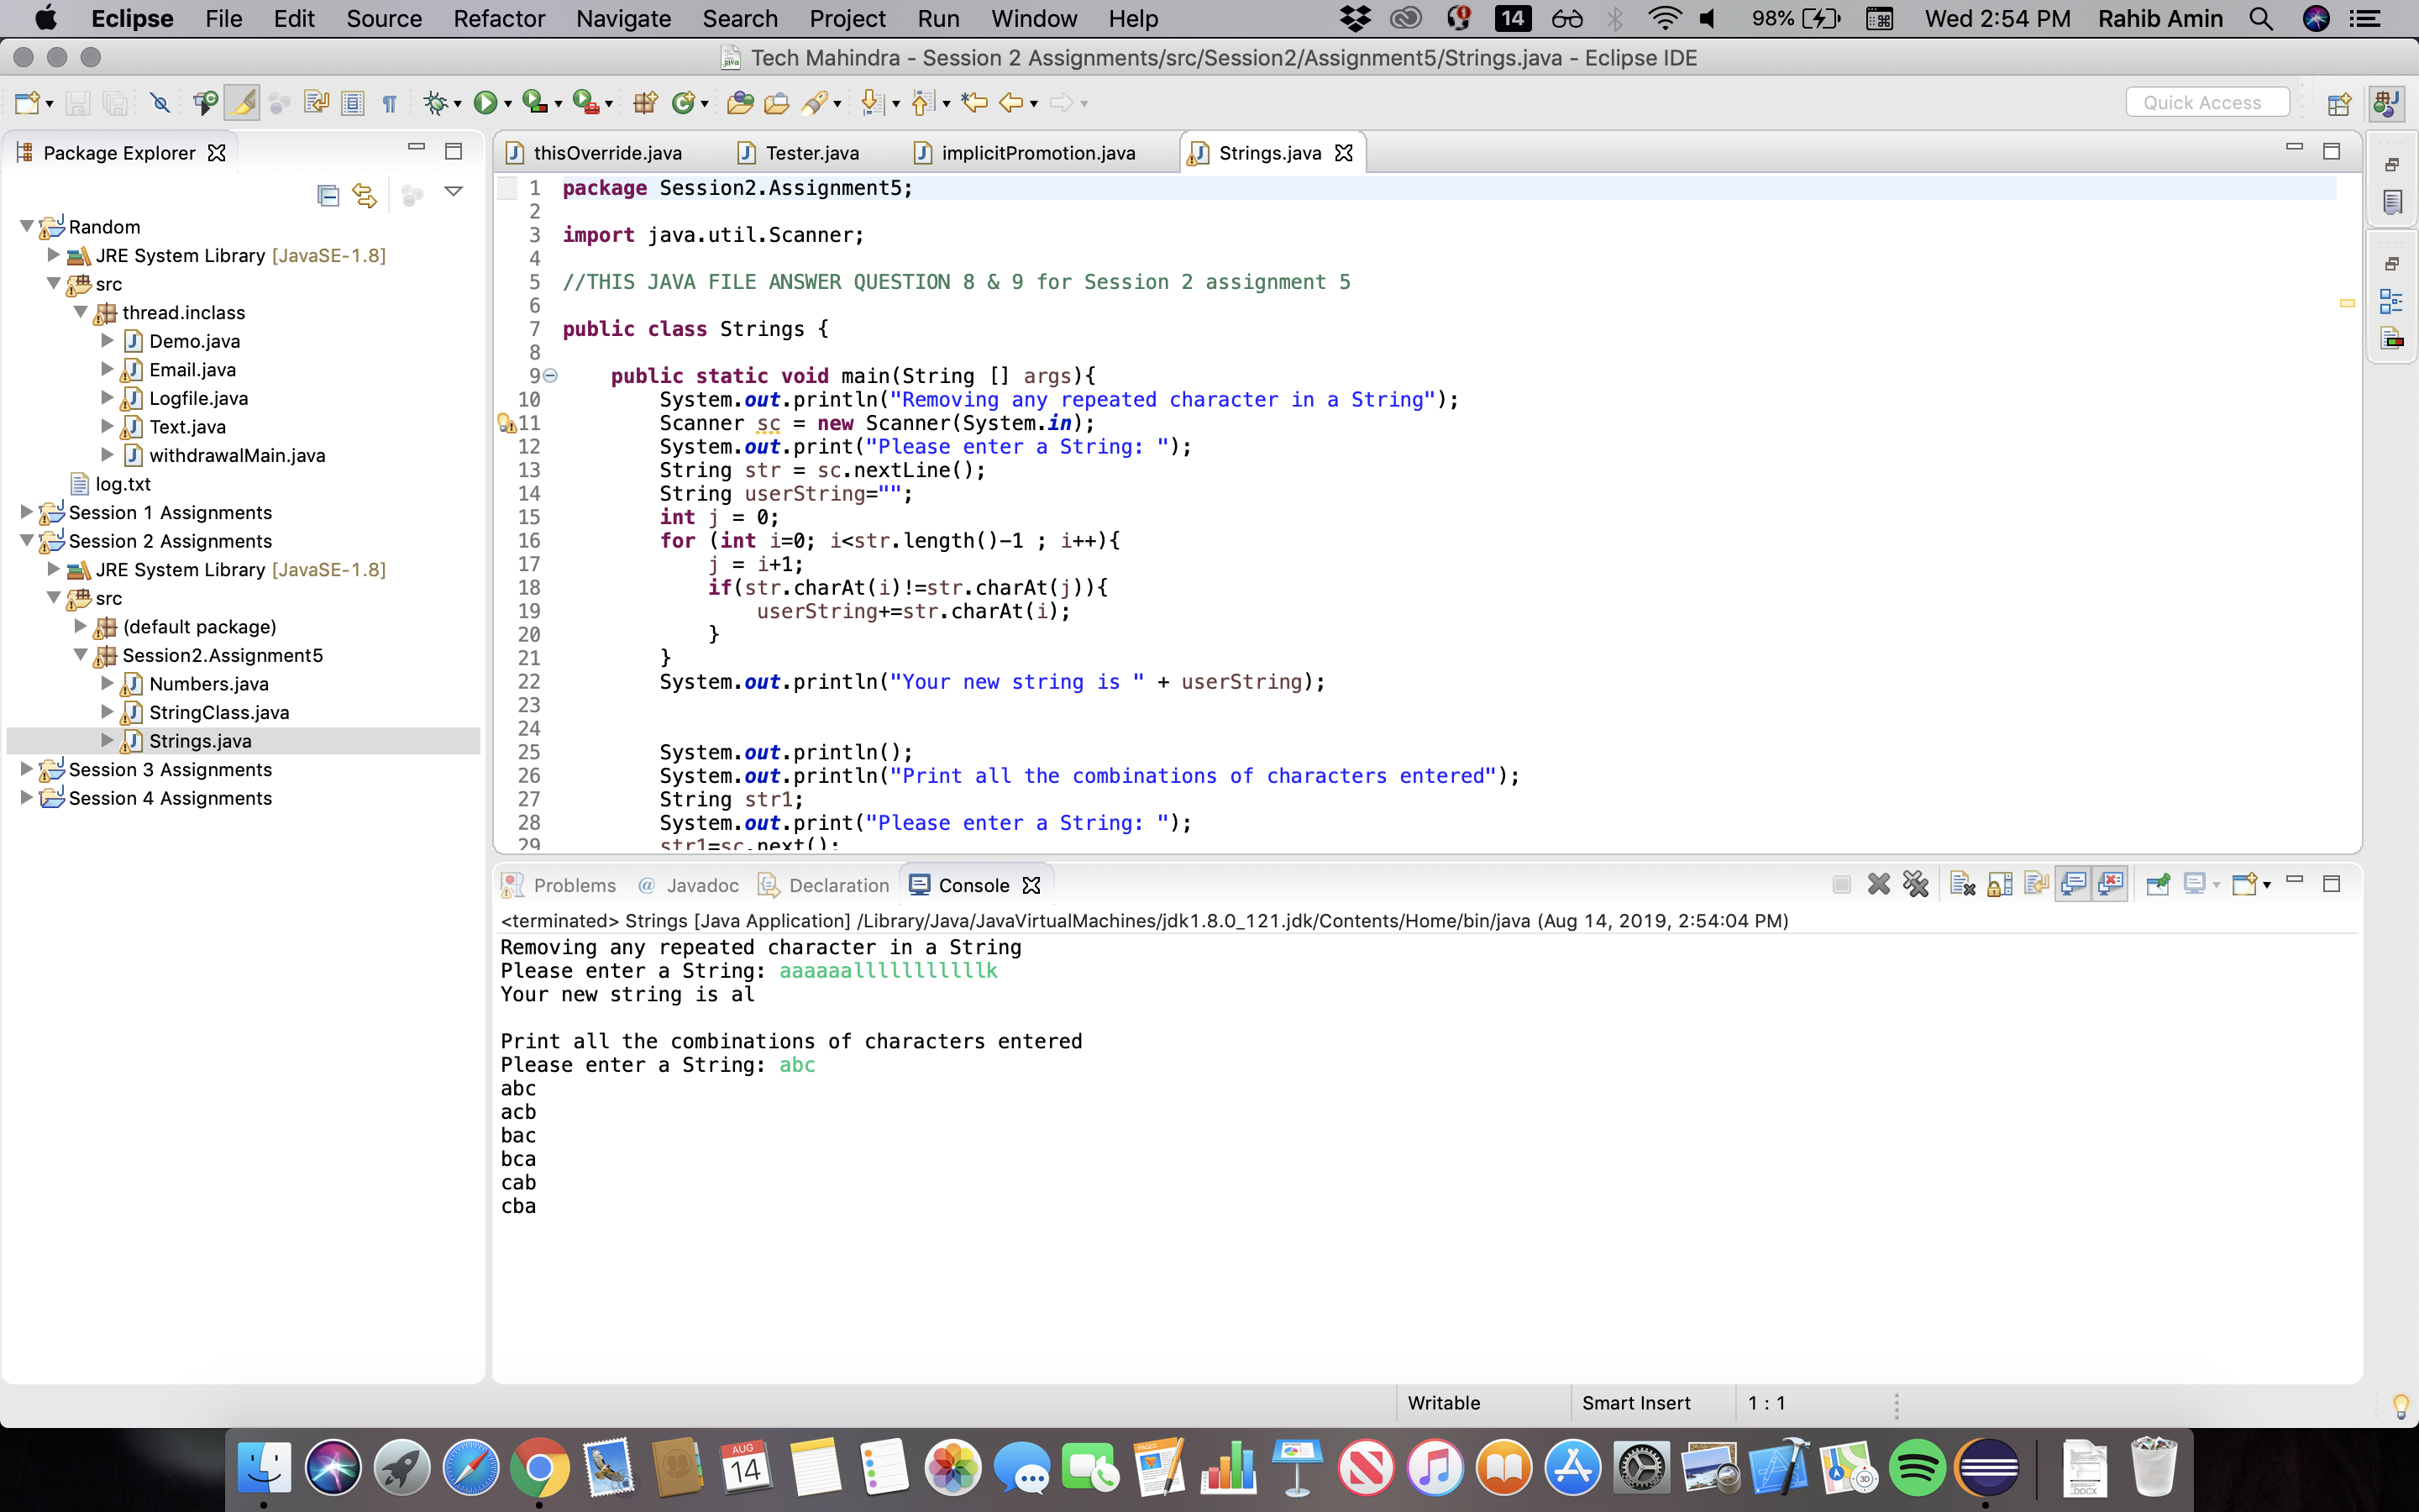

**• Ex : 3 , a b c Prints all combinations of**

**10. class Test**

**- {**

**- public static void main(String [] args)**

**- {**

**- int x=20;**

**- String sup = (x < 15) ? "small" : (x < 22)? "tiny" : "huge";**

**- System.out.println(sup);**

**- }}**

**- a. small**

**- b. tiny**

**- c. huge**

**- d. Compilation fails**

**11. class Test {**

**- public static void main(String [] args) {**

**- int x= 0,y=0;**

**- for (int z = 0; z < 5; z++) {**

**- if (( ++x > 2 ) && (++y > 2)) {**

**- x++;**

**- }}**

**- System.out.println(x + " " + y);**

**- }}**

**- a. 5 2**

**- b. 5 3**

**- c. 6 3**

**- d. 6 4**

**- 12. What will be the output of the following:**

**- class Test {**

**- public static void main(String args[]) {**

**- int x = -4;**

**- System.out.println(x>>1);**

**- int y = 4;**

**- System.out.println(y>>1);**

**- }**

**- }**

**-2 , 2**

**Answer:**

**- 13. Can we put more than one public class in single java file?**

**Answer:** You can have multiple classes within a class. They are called Inner Classes or nested classes. You can even have multiple class definitions in a single .java file without one being nested in another (provided that only one is public, because a public class has to be declared in a file named after it).

**- 14. Can we execute a program without main method?**

**Answer:** No, you cannot.

**- 15. What is the difference b/w the >> and >>> operator?**

**Answer:** ">>" is a signed right shift, while ">>>" is an unsigned right shift

**- 16. Which characters may be used as the second character of an identifier, but not**

**as the first character of an identifier?**

**Answer:** $ _ can be used as first characters

Any numbers from 0-9 can be used as second letter but not as the first letter.

**- 17. Give an example where pass by value gives an error and pass by reference**

**rectifies the statement.**

**Answer:** The main difference is when we pass by reference we are handing in our only copy of the variable, and the function directly modifies that variable, where as when we pass by value we have another variable that points at the other variable, so basically two copies of the same variable, and only the copy is modified leaving our original unchanged.